Lab 6.1 – Maximo Antigua

Refer to Tutorial 6: Working with Tables and Columns

1. Complete Session 6.1 pages HTML 454 to HTML 474

Add a screenshot of the **dir_evenings.html** file displayed in a browser after completing Step 3 on page HTML 473. Refer to Figure 6-22 for reference. Include the browser address bar.

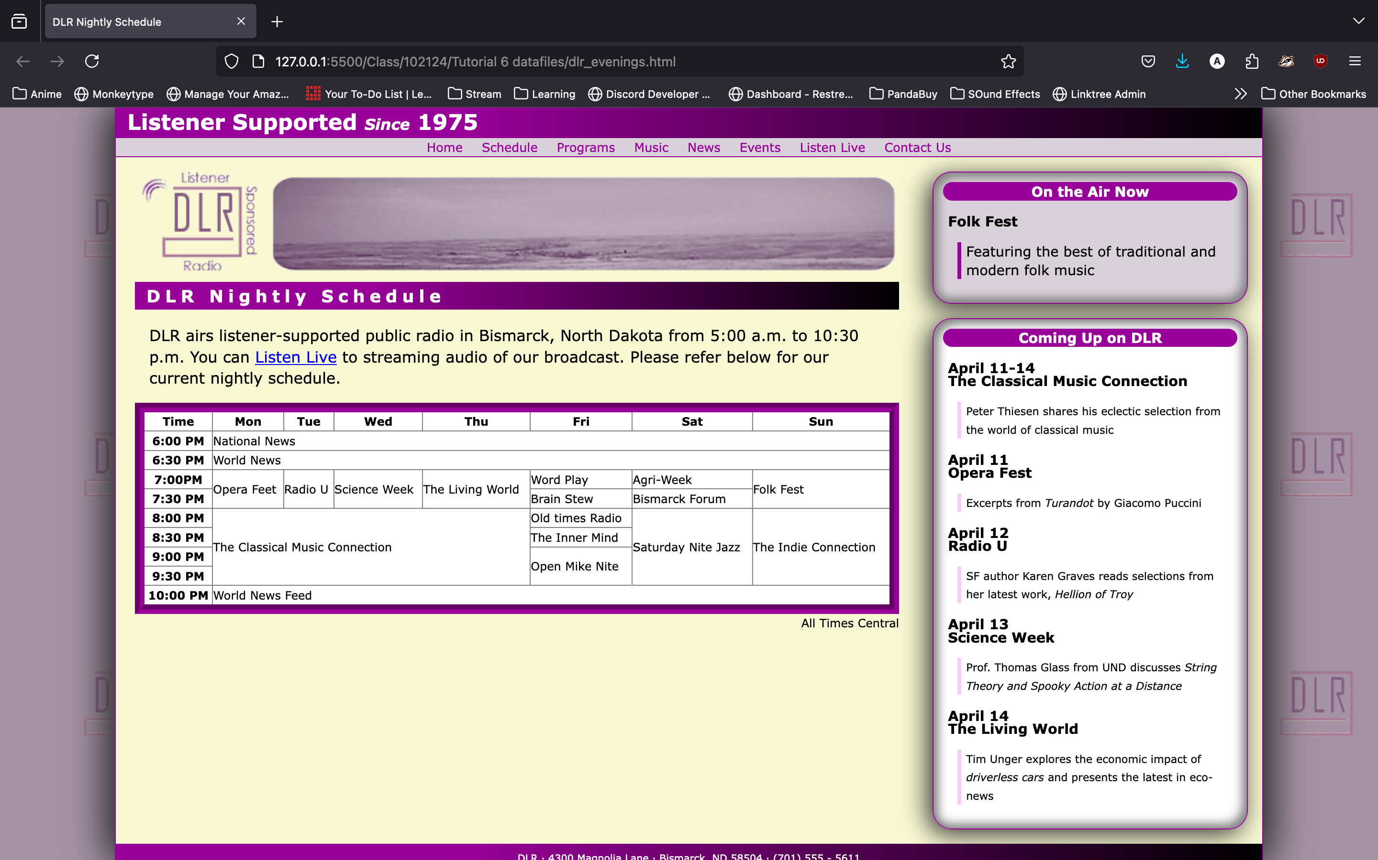

1. Complete the Session 6.1 Quick Check